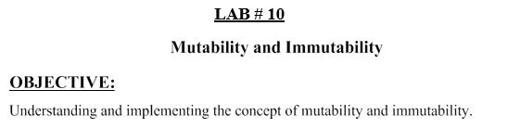

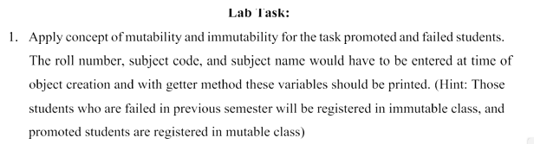

Code:

public final class FailedStudent {

private final int rollNumber;

private final String subjectCode;

private final String subjectName;

public FailedStudent(int rollNumber, String subjectCode, String subjectName) {

this.rollNumber = rollNumber;

this.subjectCode = subjectCode;

this.subjectName = subjectName;

}

public int getRollNumber() {

return rollNumber;

}

public String getSubjectCode() {

return subjectCode;

}

public String getSubjectName() {

return subjectName;

}

}

public class PromotedStudent {

private int rollNumber;

private String subjectCode;

private String subjectName;

public PromotedStudent(int rollNumber, String subjectCode, String subjectName) {

this.rollNumber = rollNumber;

this.subjectCode = subjectCode;

this.subjectName = subjectName;

}

public int getRollNumber() {

return rollNumber;

}

public String getSubjectCode() {

return subjectCode;

}

public String getSubjectName() {

return subjectName;

}

public void setRollNumber(int rollNumber) {

this.rollNumber = rollNumber;

}

public void setSubjectCode(String subjectCode) {

this.subjectCode = subjectCode;

}

public void setSubjectName(String subjectName) {

this.subjectName = subjectName;

}

}

public class Main {

public static void main(String[] args) {

// Create immutable object for failed student

FailedStudent failedStudent = new FailedStudent(123, "CS101", "Introduction to Computer Science");

// Create mutable object for promoted student

PromotedStudent promotedStudent = new PromotedStudent(456, "MA101", "Mathematics");

// Print student details

System.out.println("Failed Student:");

System.out.println("Roll Number: " + failedStudent.getRollNumber());

System.out.println("Subject Code: " + failedStudent.getSubjectCode());

System.out.println("Subject Name: " + failedStudent.getSubjectName());

System.out.println("\nPromoted Student:");

System.out.println("Roll Number: " + promotedStudent.getRollNumber());

System.out.println("Subject Code: " + promotedStudent.getSubjectCode());

System.out.println("Subject Name: " + promotedStudent.getSubjectName());

// Try to modify failed student details (will not compile)

// failedStudent.rollNumber = 124; // Compile error

// Modify promoted student details

promotedStudent.setRollNumber(457);

promotedStudent.setSubjectCode("PH101");

System.out.println("\nModified Promoted Student:");

System.out.println("Roll Number: " + promotedStudent.getRollNumber());

System.out.println("Subject Code: " + promotedStudent.getSubjectCode());

System.out.println("Subject Name: " + promotedStudent.getSubjectName());

}

}

Output:

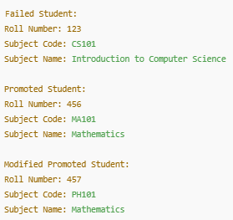

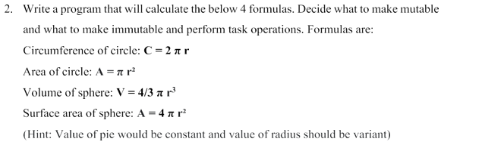

Code:  
public class CircleSphereCalculator {

private static final double PI = Math.PI; // Immutable constant

private double radius; // Mutable variable

public CircleSphereCalculator(double radius) {

this.radius = radius;

}

public double getRadius() {

return radius;

}

public void setRadius(double radius) {

this.radius = radius;

}

public double calculateCircumference() {

return 2 \* PI \* radius;

}

public double calculateAreaOfCircle() {

return PI \* radius \* radius;

}

public double calculateVolumeOfSphere() {

return (4.0 / 3.0) \* PI \* Math.pow(radius, 3);

}

public double calculateSurfaceAreaOfSphere() {

return 4 \* PI \* radius \* radius;

}

public static void main(String[] args) {

CircleSphereCalculator calculator = new CircleSphereCalculator(5.0);

System.out.println("Circumference of Circle: " + calculator.calculateCircumference());

System.out.println("Area of Circle: " + calculator.calculateAreaOfCircle());

System.out.println("Volume of Sphere: " + calculator.calculateVolumeOfSphere());

System.out.println("Surface Area of Sphere: " + calculator.calculateSurfaceAreaOfSphere());

// Change radius and recalculate

calculator.setRadius(7.0);

System.out.println("\nAfter changing radius to 7.0:");

System.out.println("Circumference of Circle: " + calculator.calculateCircumference());

System.out.println("Area of Circle: " + calculator.calculateAreaOfCircle());

System.out.println("Volume of Sphere: " + calculator.calculateVolumeOfSphere());

System.out.println("Surface Area of Sphere: " + calculator.calculateSurfaceAreaOfSphere());

}}

Output:

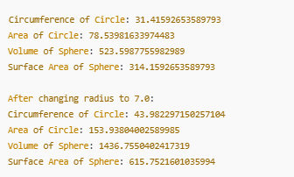

Git hub: